PACKAGING MACHINES

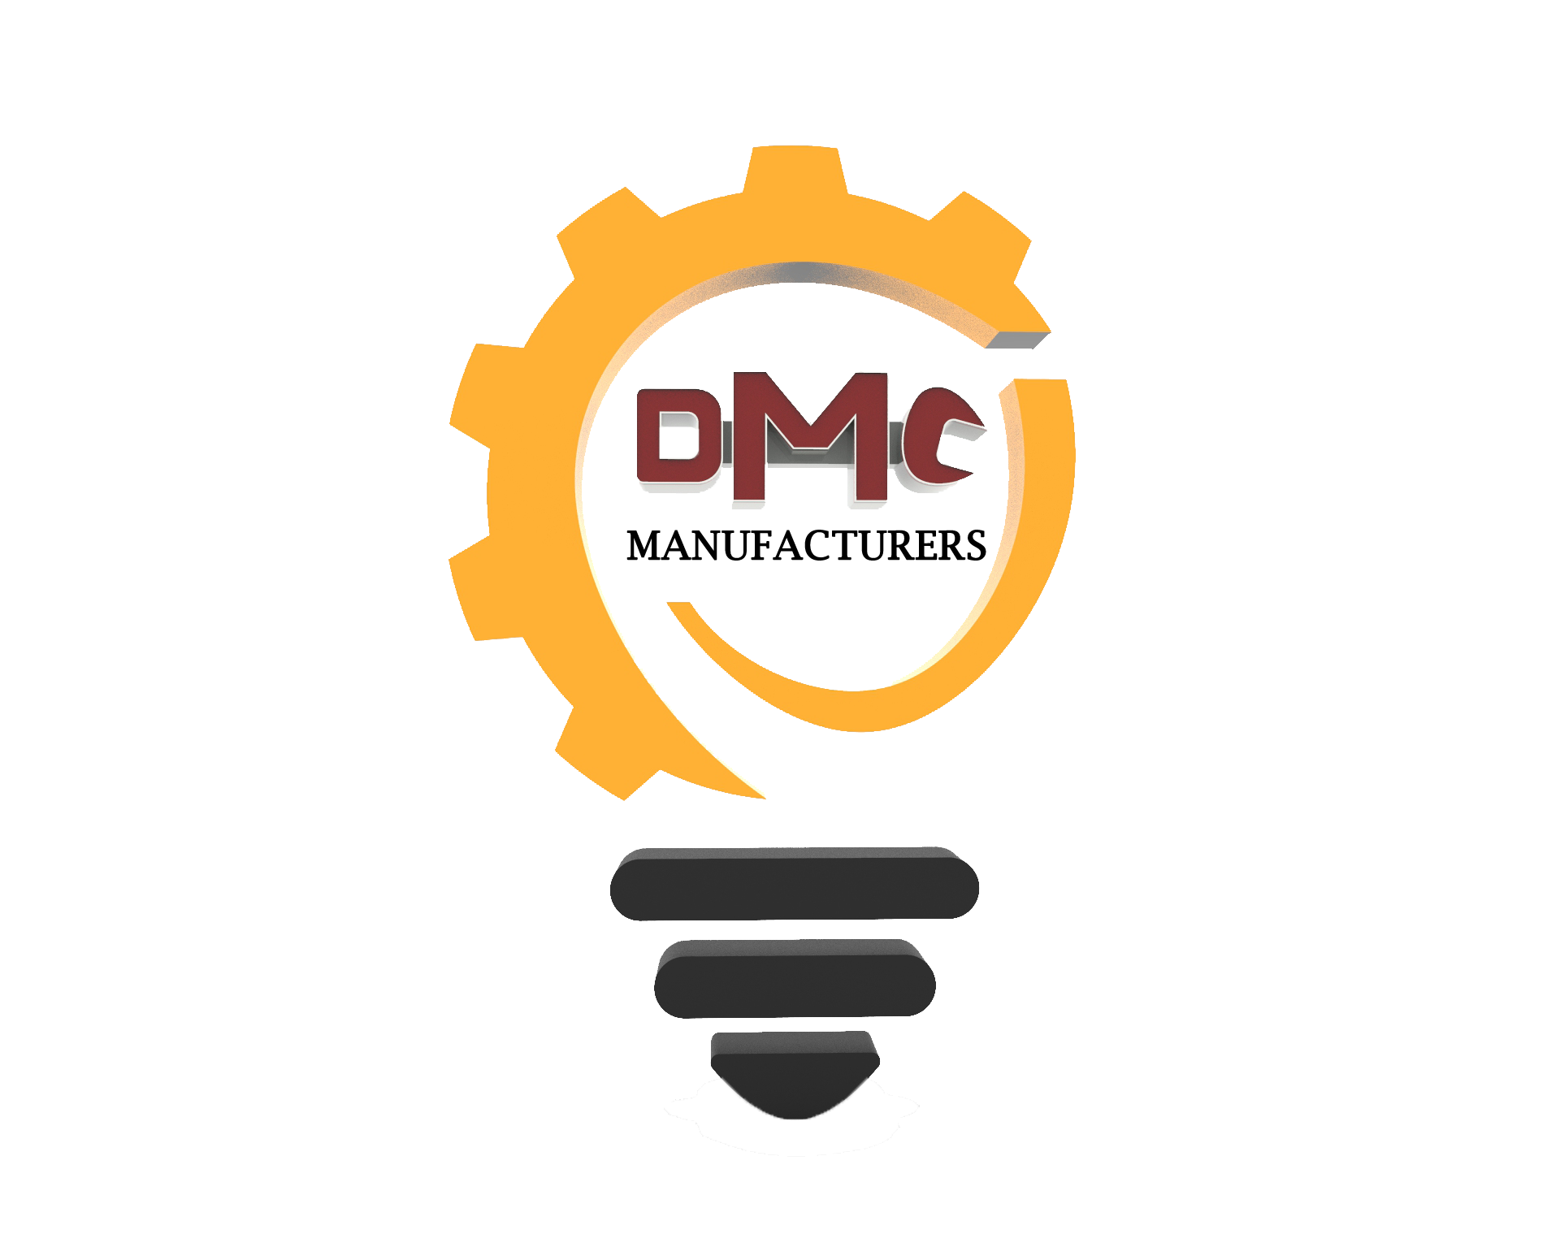

Innovative minds at work!!!

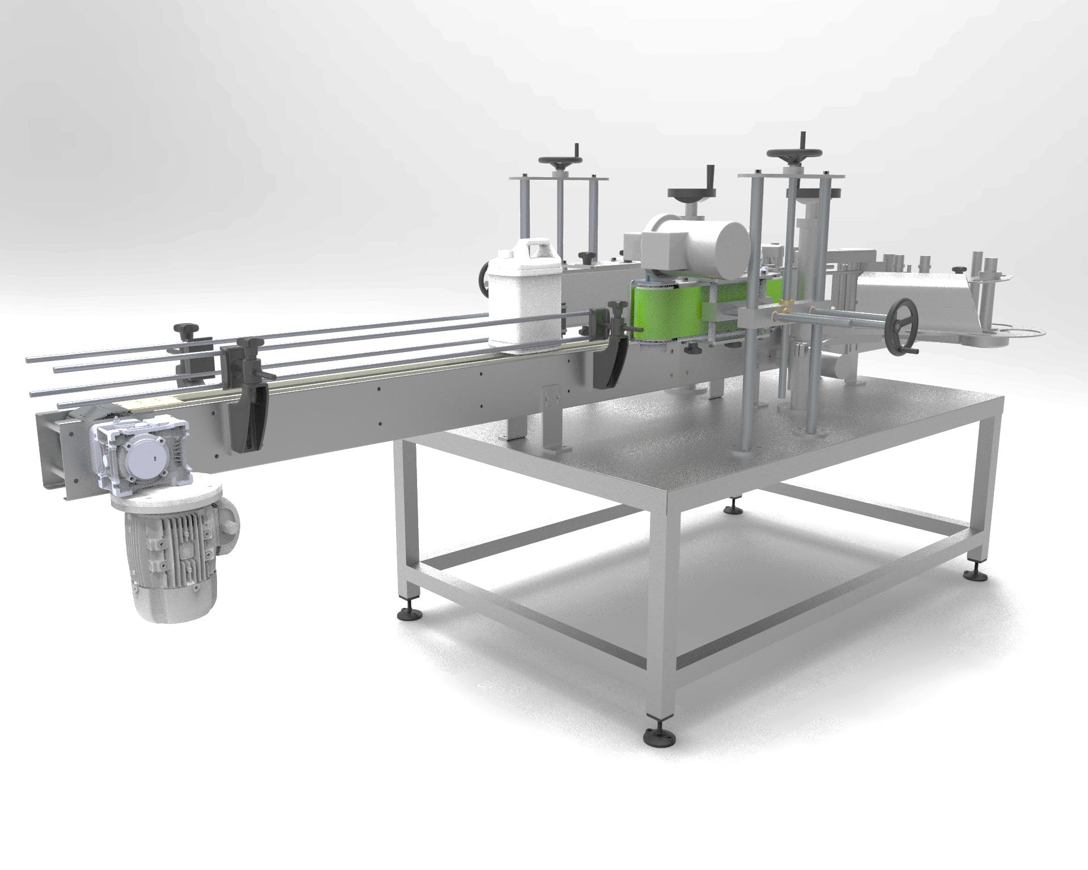

BOTTLE LABELLING MACHINE

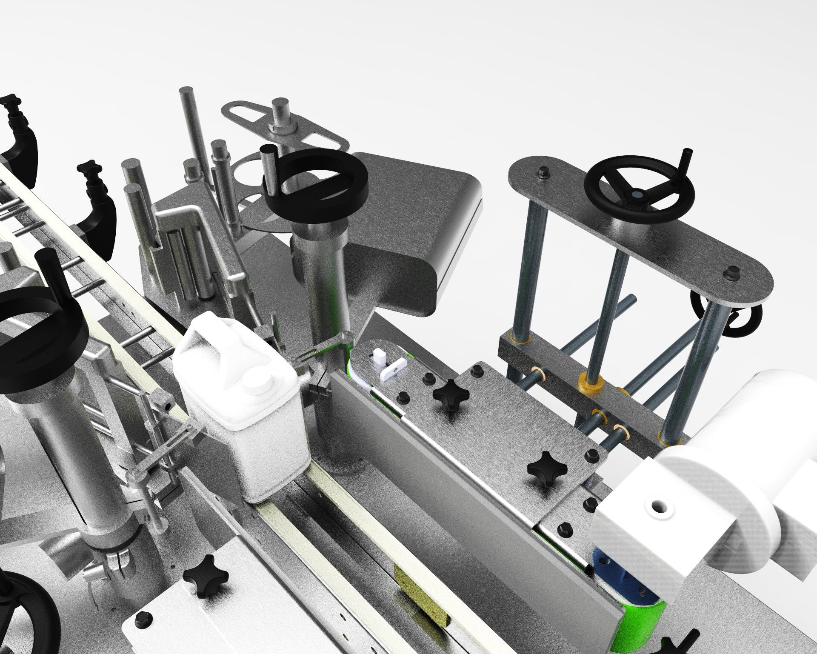

* Our automated front/back & wrap-around (combination) machine is extremely durable, efficient and easy to operate with high speed production.
* Accurate label placement.
* Different types of machines are also available for single purpose such as **Wraparound machine, Front and back machine, Top labelling machine, Hologram applicator.**
* PLC with Soft Key Pad System and product data storage facility is also available.
* Suitable for Glass, Plastic, Metal tin, Corrugated containers, Aluminium containers, jars and bottles.

**APPLICATIONS:-**

FRONT/BACK WRAPAROUND(COMBI)

FRONT/BACK WRAPAROUND(COMBI)

FRONT/BACK WRAPAROUND(COMBI)

FRONT/BACK WRAPAROUND(COMBI)

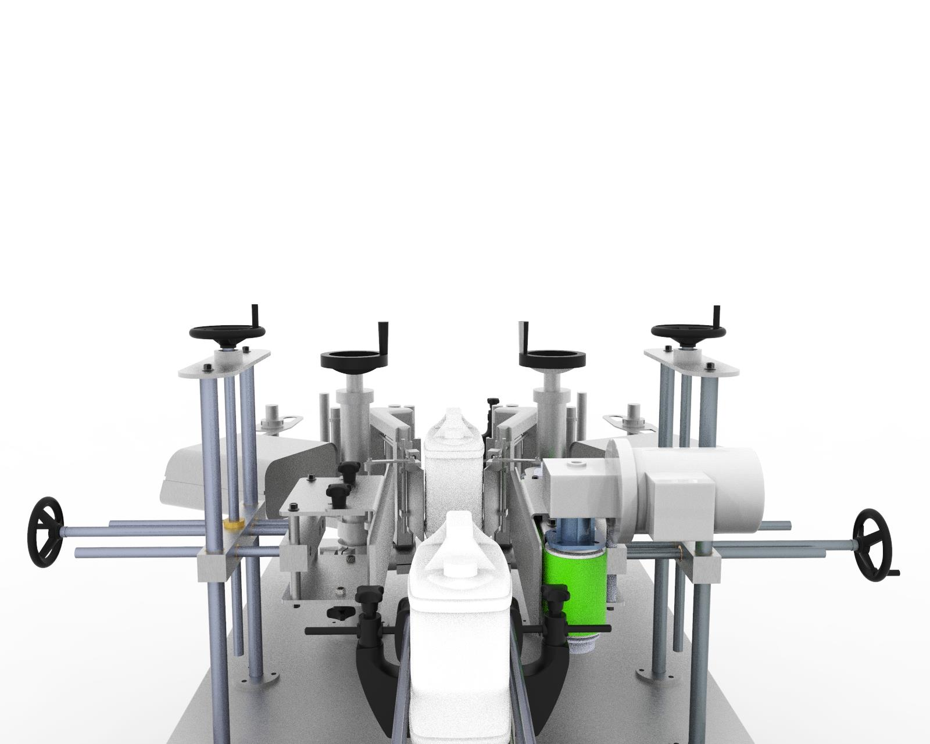

FRONT/BACK WRAPAROUND(COMBI)

FRONT/BACK WRAPAROUND(COMBI)

FRONT/BACK WRAPAROUND(COMBI)

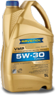

SEMI AUTOMATIC LABELLING MACHINE

**FEATURES:-**

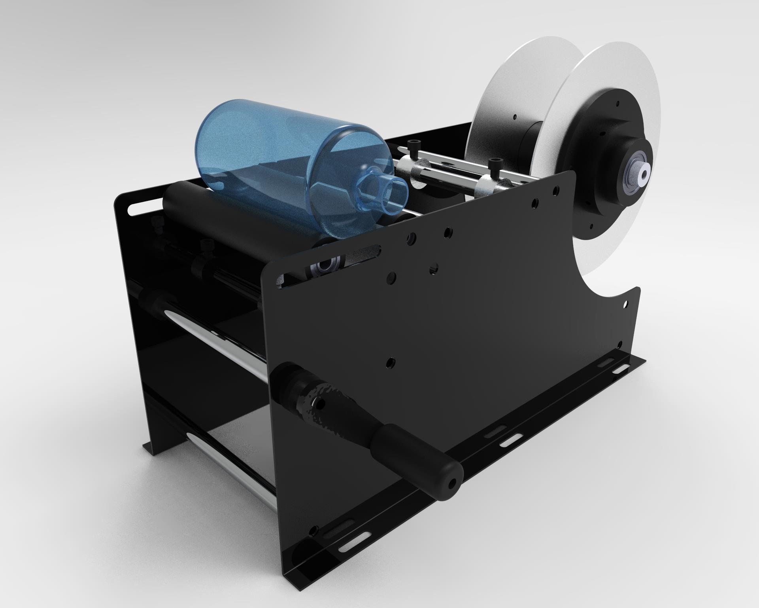

* The Semi-automatic Labelling Machine fits for a wide range of products.
* One machine can be used to achieve all the product required labelling, especially for low-volume, variety and changeable specifications labelling which can largely improve the labelling production efficiency and reduce equipment investment costs.
* The Semi-automatic Adhesive Labelling Machine is widely used in cosmetics, food, toys, daily chemical, electronics, pharmaceutical, plastics, printing and other industries, such as flat shampoo bottles, packing boxes, and cosmetic flat bottles.
* The images in the catalogue are manual type wherein a lever is provided to rotate the bottle.

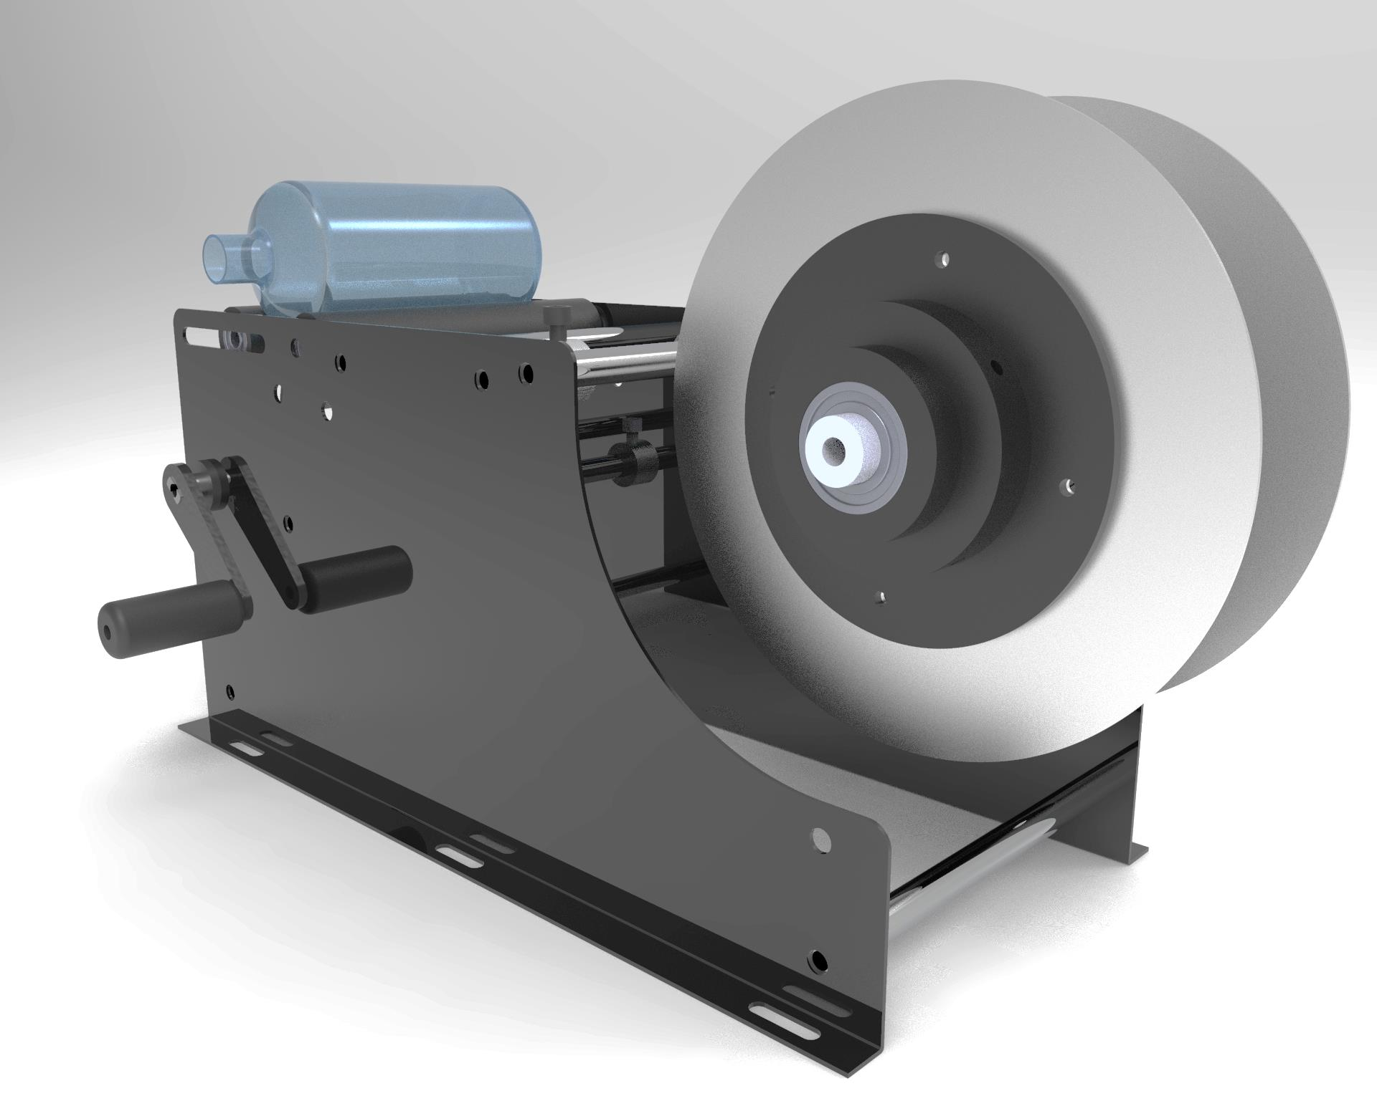

**SPECIFICATION:-**

|  |  |
| --- | --- |
| Voltage | AC 220 V + 10 V + 50 HZ -120 W |
| Labels accuracy | + 0.5 mm. |
| Label speed | 25-50 pcs/min |
| Label roll liners | Dia =75 mm |
| Max label roll | Dia =200 mm |
| Product | Dia =10-100 mm |
| Width of labels | 8-100 mm , L=15-200 mm |
| Machine size | 650 x 450 x 550 mm |
| Gross weight | 50 kg |

BOTTLE FILLING & CAPPING MACHINE

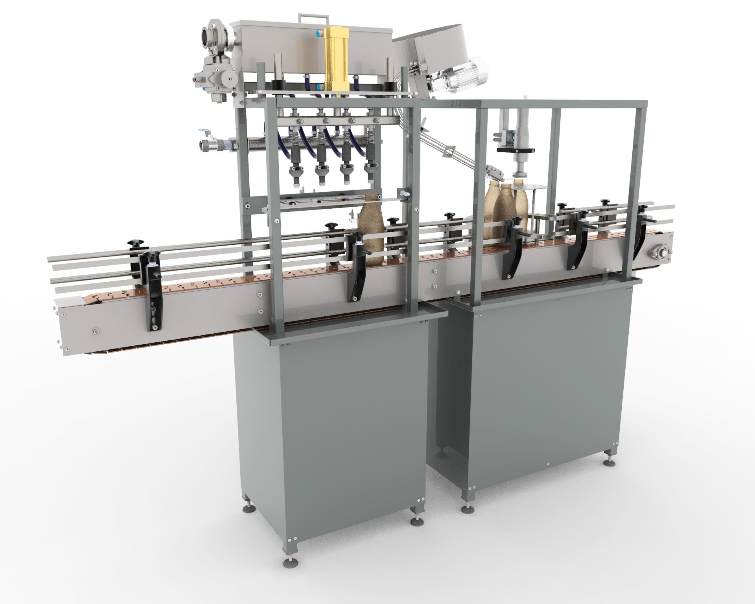

* Filling machines are used for [packaging](https://en.wikipedia.org/wiki/Packaging), mainly for food/beverage but for other products as well. These are used to fill either a bottle or a pouch, depending on the product.
* There are several types of fillers used by the packaging industry like Agitator fillers, Vibratory weigh fillers, Flow fillers, Tablet fillers, Positive displacement pump fillers, Tube filling machine etc.
* **FEATURES:-**

1. Compact and elegant design.
2. No change over required for different volumes.
3. More than 0.5% filling accuracy.
4. Pneumatically controlled drip free mules.
5. Pneumatic bottle stopping arrangement.

* **SPECIFICATIONS:-**

|  |  |
| --- | --- |
| Capacity | 10-100L |
| Size/Dimensions | 10-100mm |
| Electrical specification | 3Ph / 415 V |
| Filling range | 10-1000ml |
| No. of filling heads | 2,3,4-6 |
| Cap range | 15-130mm |
| Torque range | 5-250lbs |

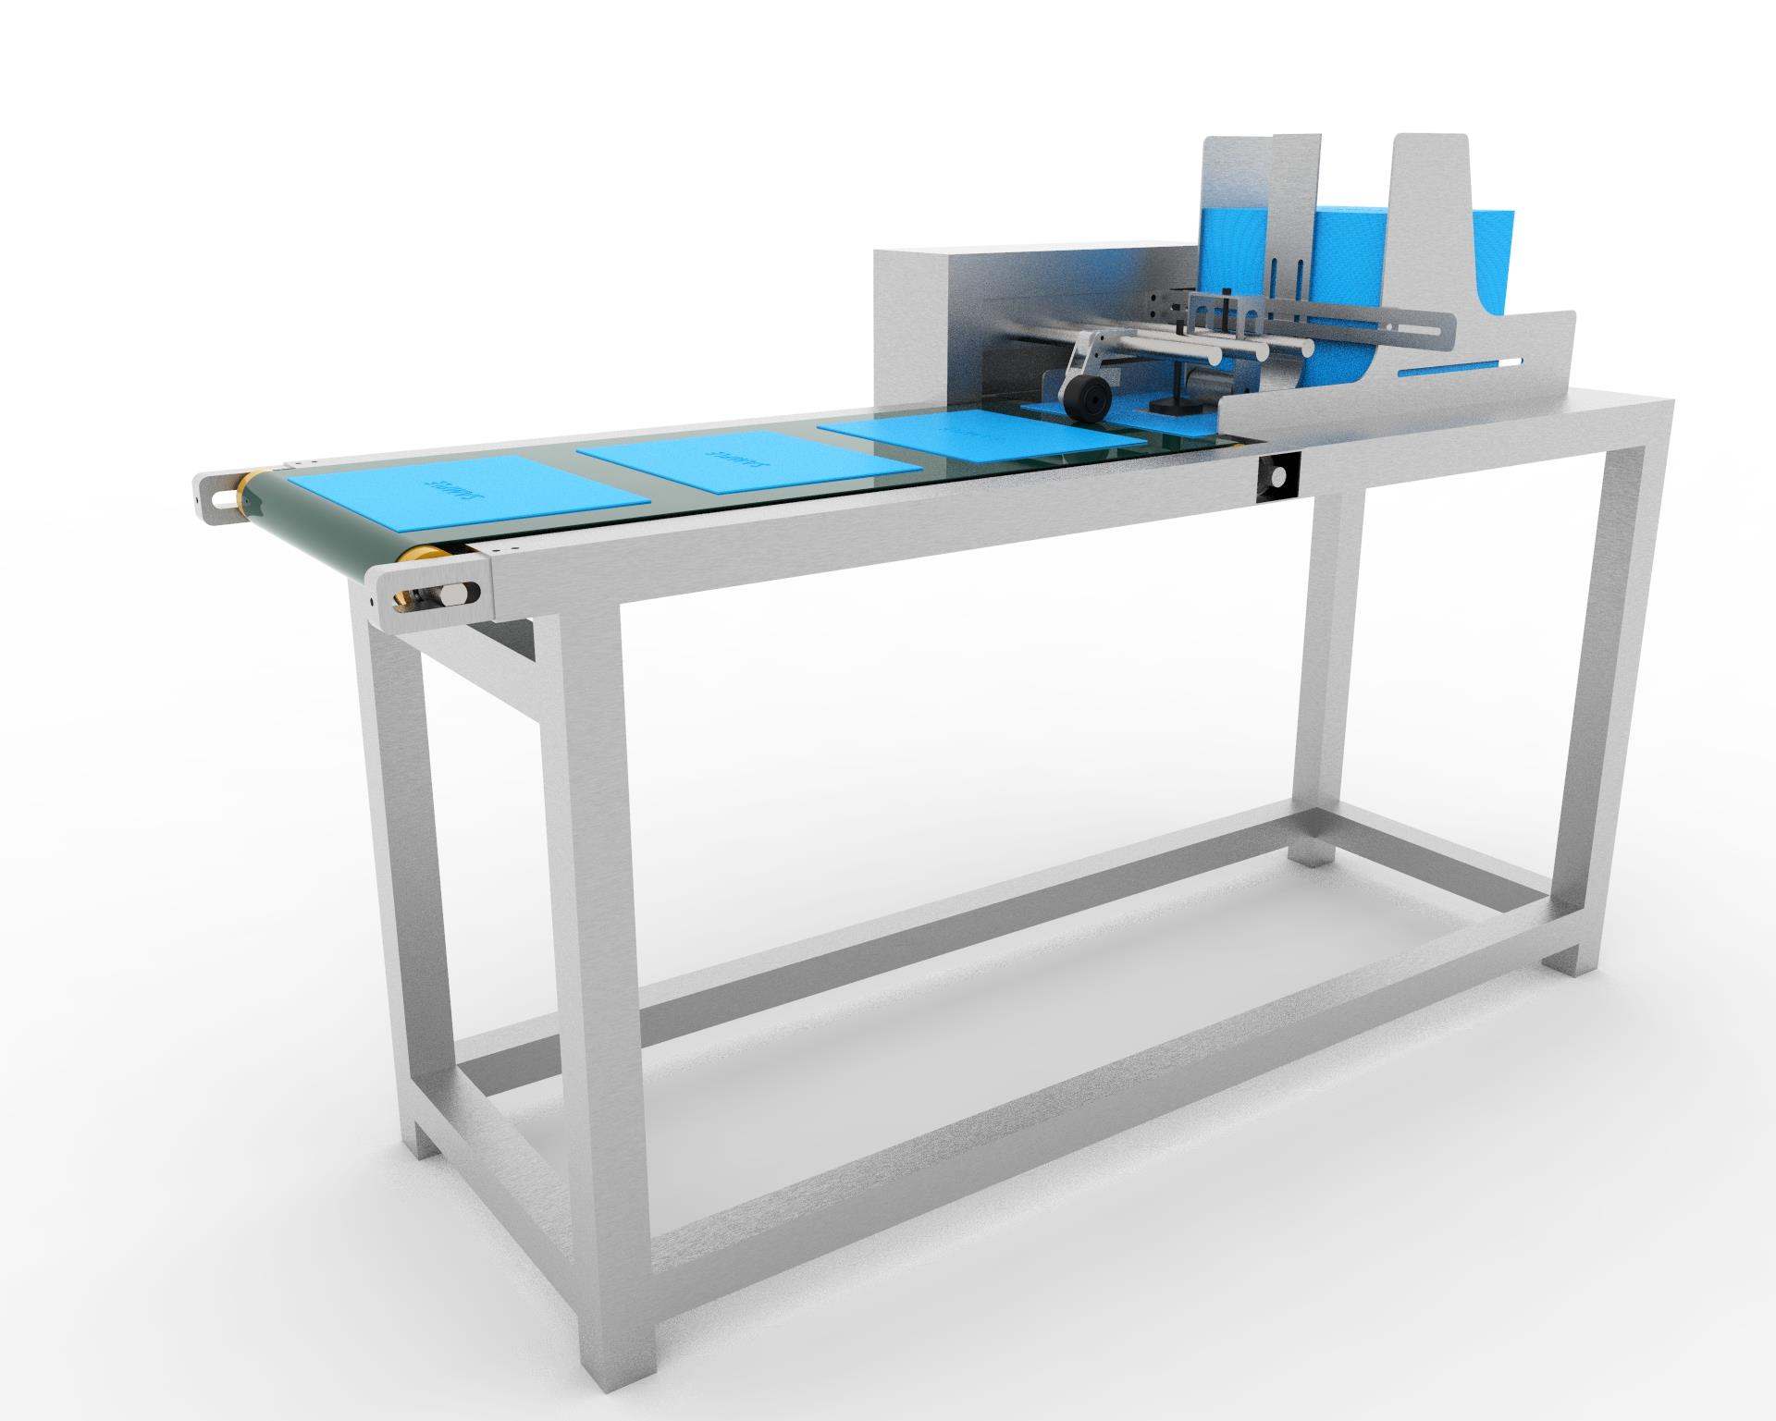

FRICTION FEEDER

**FEATURES:-**

* Single product filling machine.
* Flat belt dispensing units, horizontal or vertical.
* Separate control box with integrated PLC.
* Adjustable Loading sack.

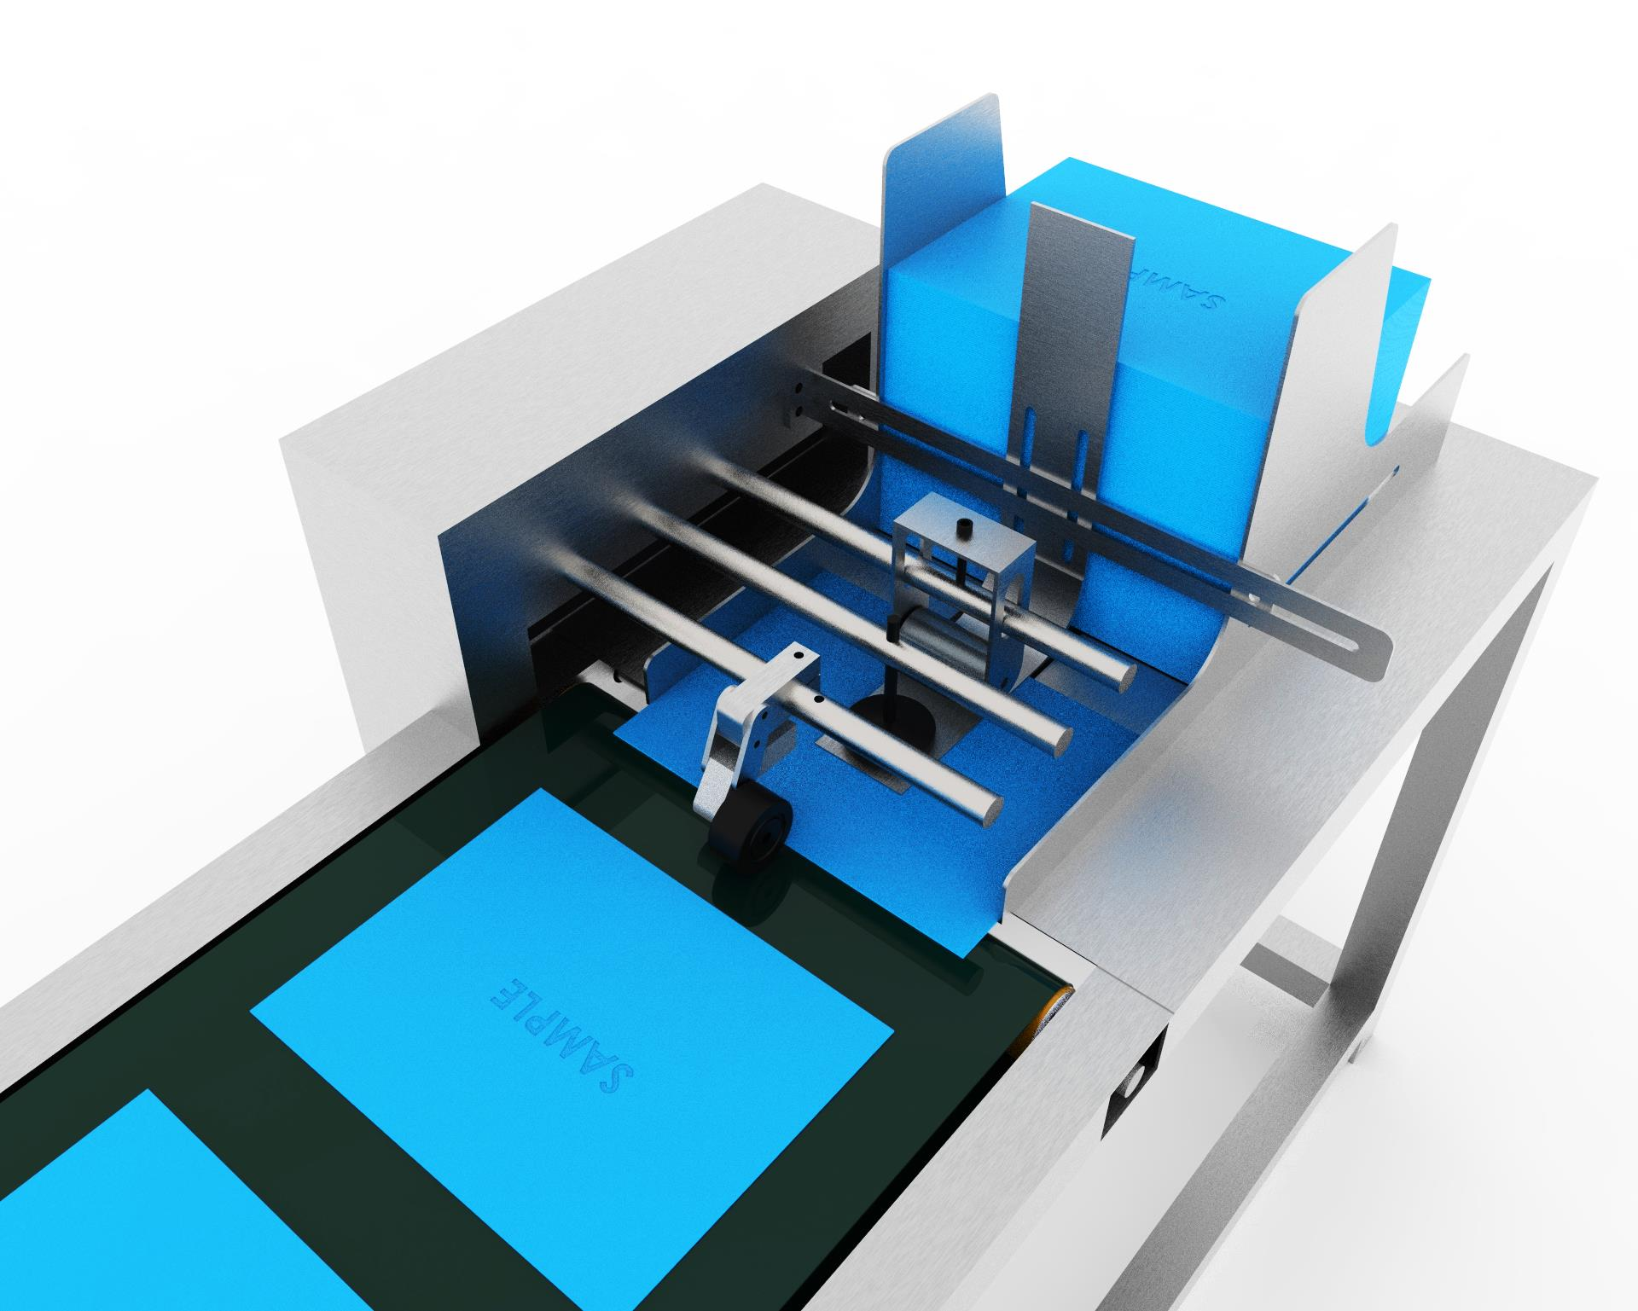

**SPECIFICATIONS:-**

|  |  |
| --- | --- |
| Dispensing speed | 400pc/min (depending on product step) |
| Product thickness | 0.2-3mm |
| Product sizes | From 10-500mm width & length |
| Power supply | 230V/50-60Hz |

TYPE 1

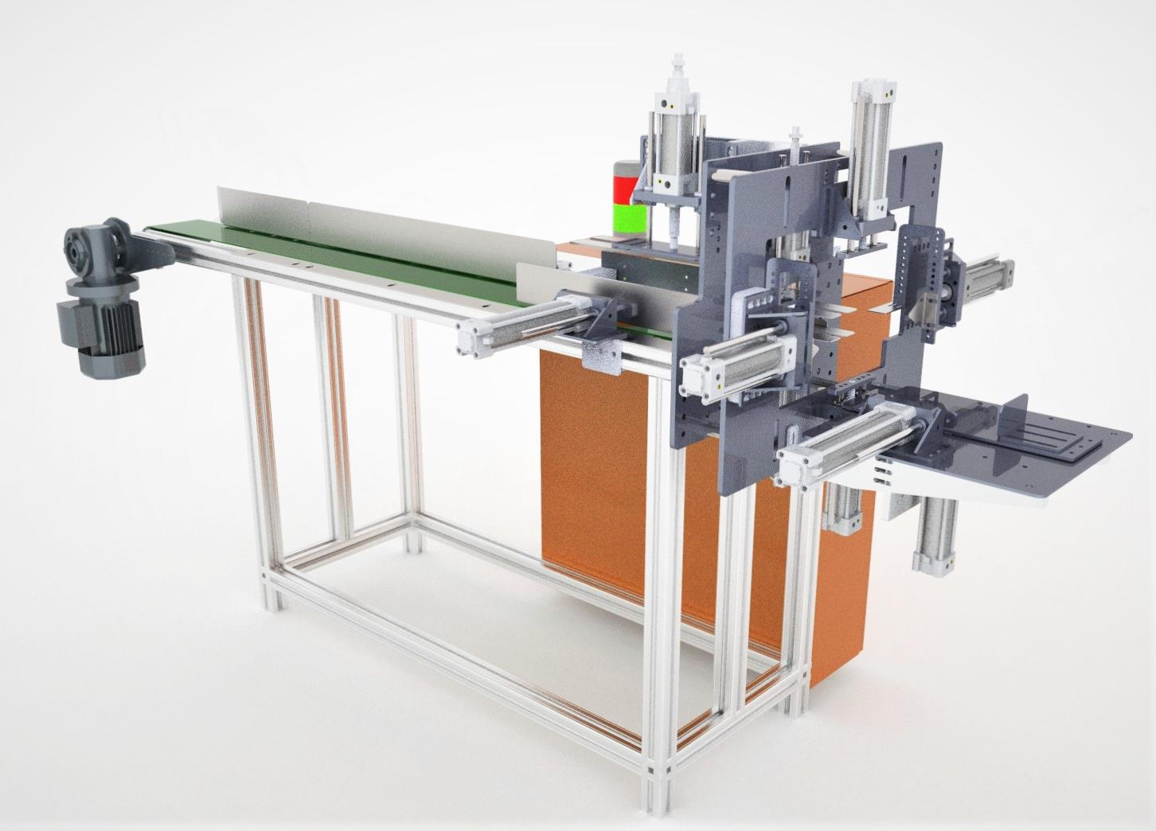

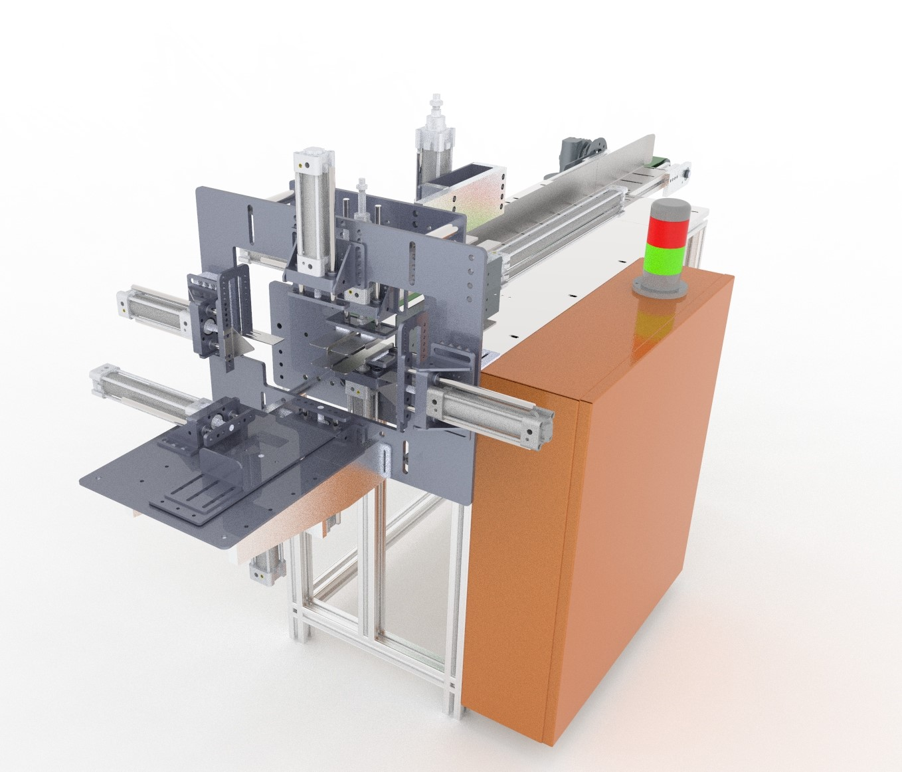

TYPE 2

1. Single Head Machine

SANITARY PAD PACKING MACHINE

**B) Double Head/ Two Head Sanitary pad packing machine.**

**Specifications:-**

* Packing of both Tri-fold and long pad can be done.
* Long pad range 6,7,etc.
* Long pad length 240, 280 &320mm.
* Tri-fold range 6-18pc per pack.
* Tri-fold length 240, 280 &320mm.
* Ultra thin, soft, comfort, XL, XXL all types of width are covered in this machines.
* More production speed than single head machine.

**Description:-**

* This machine is used to pack sanitary pads with or without tri-fold.
* All the contact parts are made with Stainless Steel 304 to ensure proper safety from corrosive environments while packing.
* PLC programming and a 8’’ HMI display ensurers proper user interface with the machine, providing all the necessary commands installed to manually feed the settings as per required.

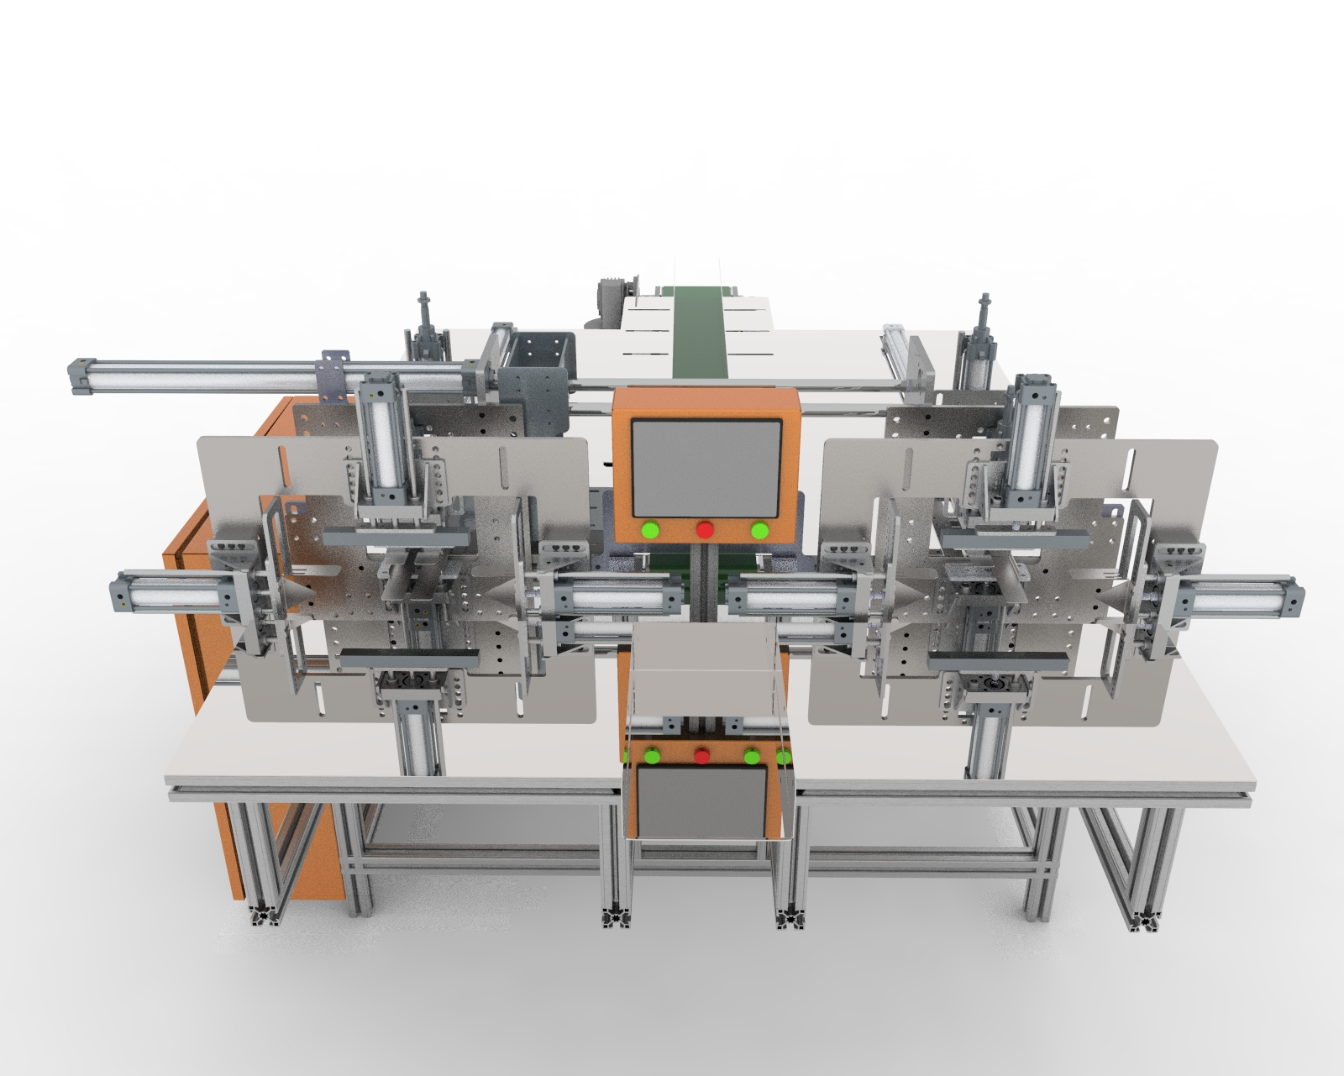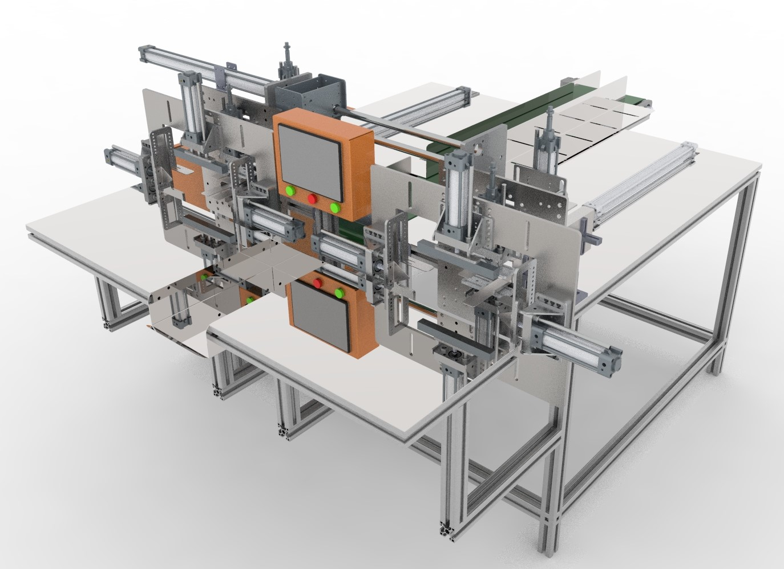

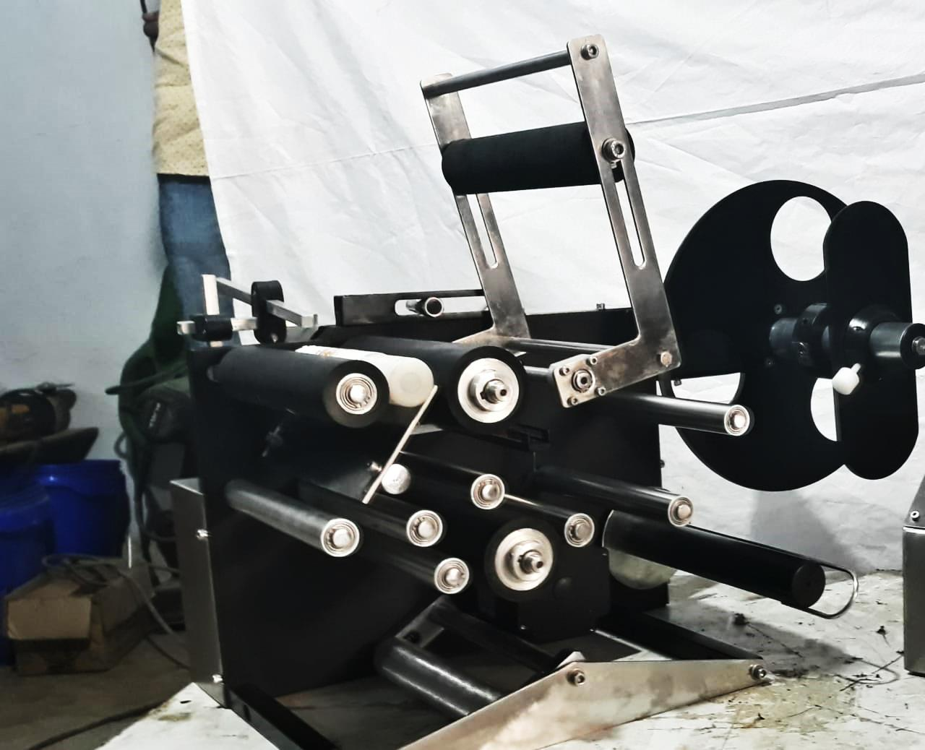

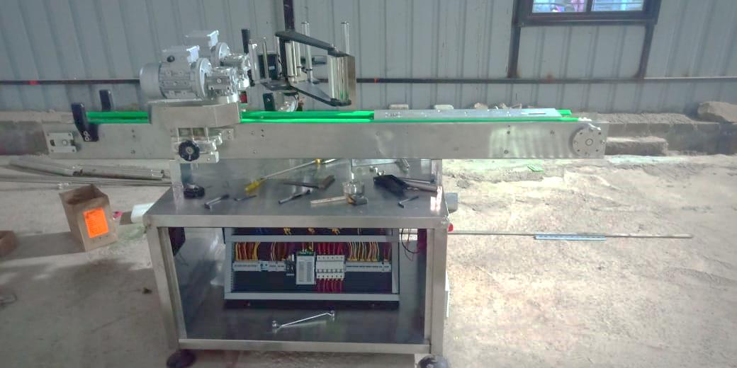

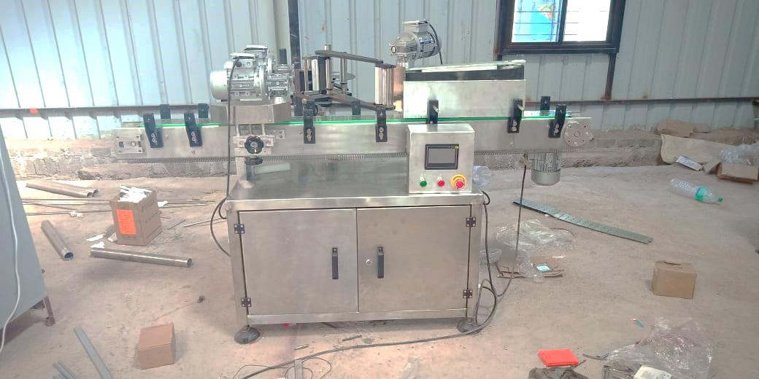

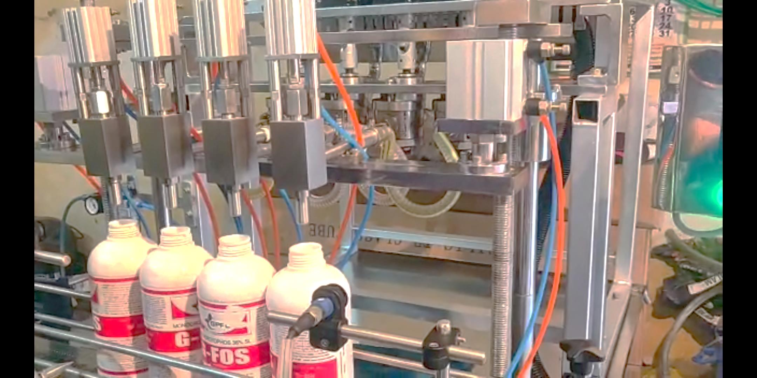

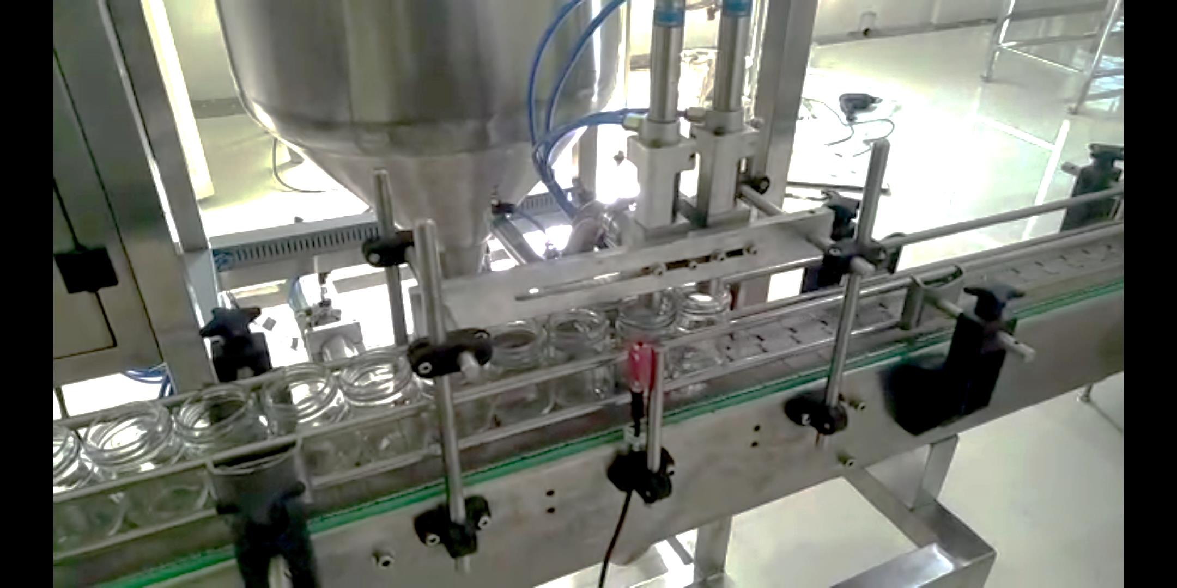

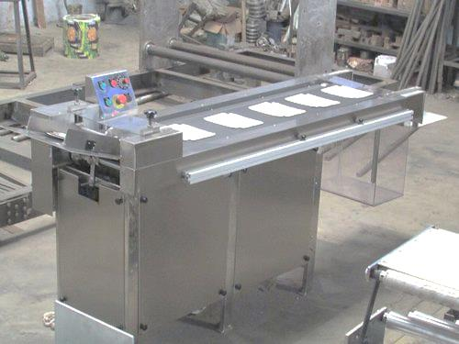



For Enquiries Contact:  
**DMC MANUFACTURERS**  
**WORKS & OFFICE**: Shop no.3, Opp to GS Mahanagar Bank, Triveninagar, Talawade road, Pune-412114.  
**Mob. No.:** (+91) 9790722190 / 7276897580 .  
**E-mail Id**: [dmcmanufacturers4@gmail.com](mailto:dmcmanufacturers4@gmail.com)  
**Website**:- www.dmcmanufacturers.com